CS 4336.0U1

Jackson Cowdrey, jtc190004

Rafae Ahmad, rsa190001

Semester Project Screenshots:

1st screen:

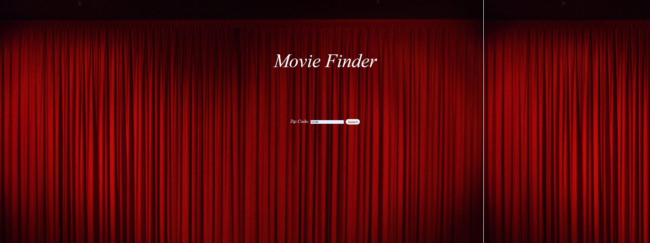

2nd screen:

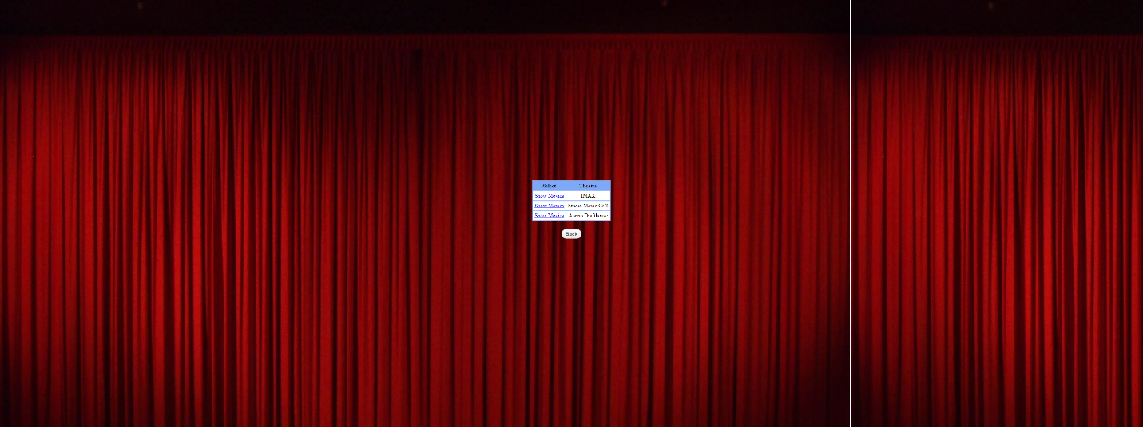

3rd screen:

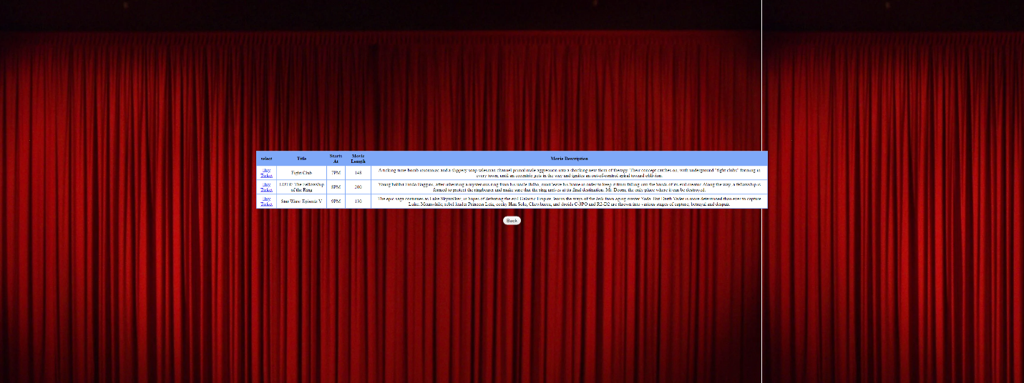

4th screen:

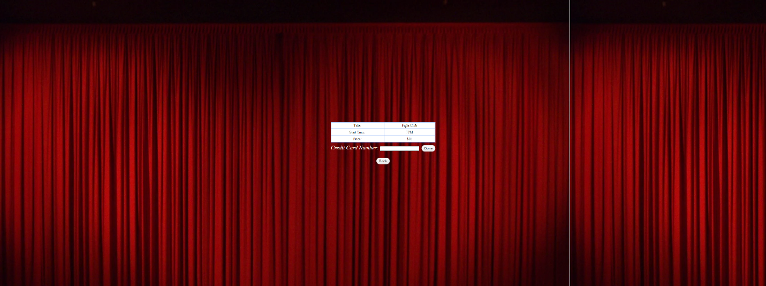

5th screen:

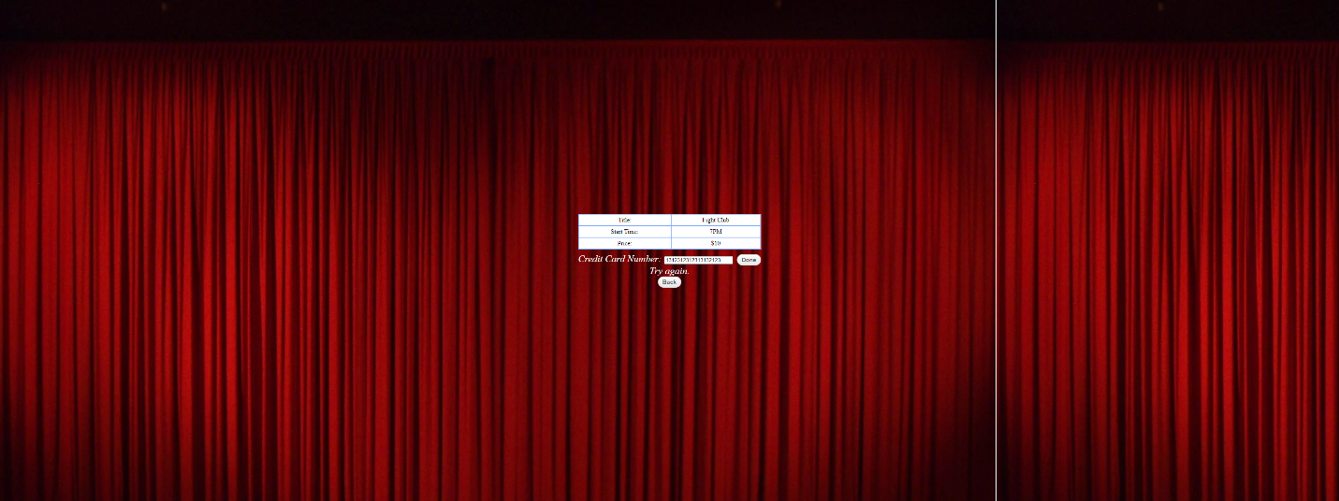

6th screen:

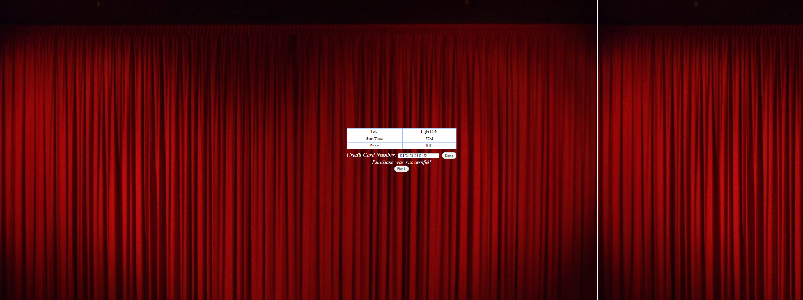

Note: These images were taken on an ultrawide monitor, so you might have to download them to view them in a higher fidelity than what is shown here.